|  |
| --- |
|  |
| Capstone Project Document |

**VIETNAMESE MEDICINAL PLANTS NETWORK**

Report #1 – Project Introduction

|  |  |  |
| --- | --- | --- |
| **Vietnamese Medicinal Plants Network** | | |
| **Group Members** | Nguyễn Minh Tiến | SE02545 |
| Trần Bình Khánh | SE02764 |
| Nguyễn Hải Đăng | SE02992 |
| Hoàng Thị Quỳnh | SE02639 |
| **Supervisor** | Mr. Nguyễn Văn Sang | |
| **Project code** | VMN | |

**- Hanoi, 01/2016 –**

# SIGNATURE PAGE

AUTHOR: Hoàng Thị Quỳnh 13/01/2016

Team member

Trần Bình Khánh 12/01/2016

Team member

REVIEWERS: Nguyễn Minh Tiến 14/01/2016

Project manager

APPROVAL: Nguyễn Văn Sang --/--/--16

Supervisor

Record of change

*A - Added M - Modified D – Deleted

|  |  |  |  |  |  |
| --- | --- | --- | --- | --- | --- |
| Effective Date | Changed Item | A,M,D | Change Description | Reason for Change | Rev. Number |
| 15/Jan/2016 | Create Introduction | A | Create Introduction | First version | 1.0 |
| 22/Jan/2016 | System features | M | Describe detail 2 types of article Medicinal plant and remedy | Re–define entity relation | 1.1 |
| 19/Apr/2016 | Potential risk | M | Describe clearly potential risk of doing project time |  | 1.2 |
|  |  |  |  |  |  |
|  |  |  |  |  |  |
|  |  |  |  |  |  |
|  |  |  |  |  |  |
|  |  |  |  |  |  |
|  |  |  |  |  |  |
|  |  |  |  |  |  |
|  |  |  |  |  |  |

Table Contents

SIGNATURE PAGE 1

1 INTRODUCTION 3

1.1 Purpose 3

1.2 Acronyms and Definitions 3

2 ABSTRACT 3

3 LITERATURE REVIEW 4

4 PROPOSAL 6

4.1 The idea 6

4.2 Objectives 6

4.3 Brief description about system 7

4.4 System features 8

4.4.1 Client features 8

4.4.2 Admin features 8

5 BENEFIT FROM PROJECT 9

5.1 For our group 9

5.2 For Community 10

6 CRITICAL ASSUMPTION AND CONSTRAINTS 10

7 POTENTIAL RISKS 10

8 REFERENCES 10

# INTRODUCTION

## Purpose

This document is created as the introduction for project Vietnamese Medicinal Network System – our Capstone Project at FPT University. In this document, we will describe the overview of some existing systems, the initial idea for our project, a brief description about our expected system and some potential risks, critical assumptions, constrains. Moreover, this document also shows opportunities what it offers for users.

## Acronyms and Definitions

|  |  |
| --- | --- |
| **Acronym & Abbreviation** | **Definition** |
| VMN | Vietnamese Medicinal Network System |
| FU | FPT University |
| Q&A | Question and Answer |

**Table 1-1:** Definitions and Acronyms

# ABSTRACT

Nowadays, thanks to the development of the medicine, not only human’s health but also living quality are improving.

15 year ago, visceral surgery always made you got 15cm scar but few year ago, basing on new surgery technology- minimally invasive techniques, patients can escape from fears of this scars.

Or spectacular developments from stem cell research, over 100 diseases can be cured by using this method all over the world such as Genetic diseases, the immune, Chronic diseases, cancer …

However, the more developing life is the busier people becomes by jobs, family and children, we misuse on medicine (special western medicine) too much. For example, when you get fever, you regularly find: paracetamol, advil, …When you get cough, just few of clicks, you can find out tylenol, robitussin, …etc. The effective of pharmaceutical is so quick but adverse effects cannot be measured.

Moreover, not only jeopardies harm to healthy, high price is a problem that users need to thinking. 4/2014 Thanh Hoa city’s Economic Police detected 1,2ton western medicine low quality, fake label, smuggled from China. 11/2014 Ha Noi Economic Crime investigate Police found over 3000 products for women and children are be faked. 8/2015 big size line of producing and consuming western medicine was arrested at HCM. We ask by ourselves that how many boxes of fake medicine and fake blister packs are selling outside? Are you asking by yourself to your family’s healthy …

When you get cough, instead of searching tylenol, robistussin, why don’t you drink a cup of honey with lemons.

When you get fever, why don’t you find eclipta prostrata, comminute, then get water and drink. This remedy is very helpful with children.

Cheap, easy to find, adverse effects nearly zero are strong advantages of these remedies. So, anxiety status quo of western medicine that we mentioned, why don’t you think about natural, folk, and forefathers’ experiences, think about medicinal plants and traditional remedies.

Aims to health of community, we’re thinking a new system, where member can search, study about medicinal plants, remedies. More than that, they can contribute, share experiences. They also can search reliable herbal medicine store. Vietnamese herb medicine store has ability to share their remedies, also address to contact for members…

# LITERATURE REVIEW

With object is sharing information about medicinal plants, traditional remedies to community, we found out same idea websites such as: thuocnam.org, tuelinh.vn, caythuoc.info:

* **thuocnam.org**

Thuocnam.org is a website that provide information about medicinal plants and remedies.

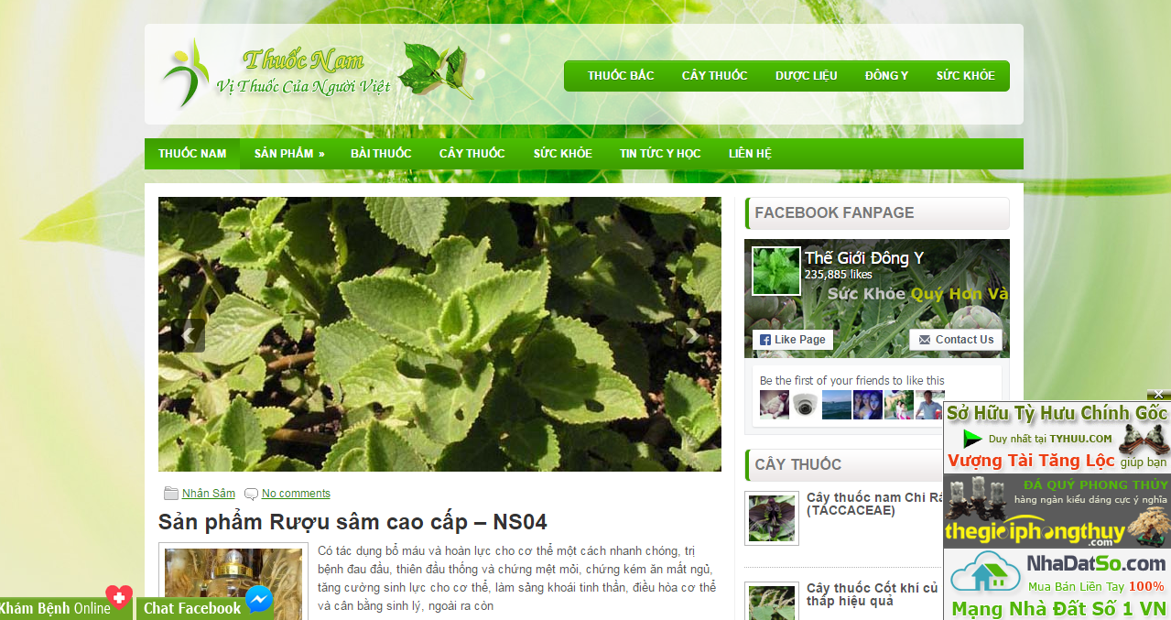

Figure 3‑1: Website thuocnam.org

* **Advantages:**
* The information about medicinal plants and remedy are diversified.
* **Disadvantages:**
* Interactive level is not high such as user cannot search information, cannot rate, user also cannot share their experiences...
* The information of Vietnamese herb medicine store is not included.
* **Tuelinh.vn**

Tuelinh.vn is a website belongs to Tue Linh company. The website provides information of medicinal plants, company’s products, …

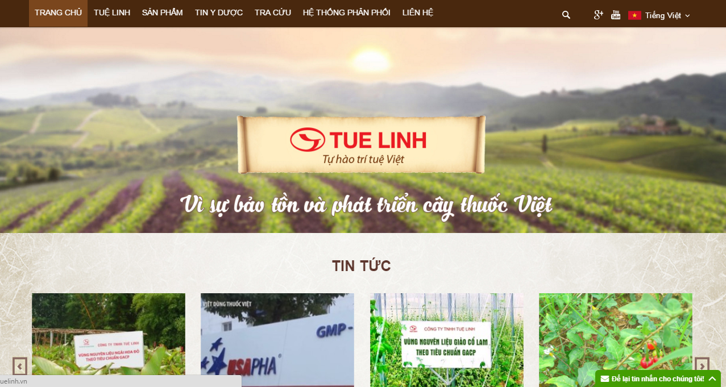

Figure 3‑2: Website Tuệ Linh

* **Advantages:**
  + Friendly user interface.
  + High reliability and diversity of information.
* **Disadvantages:**
  + This page is built for specific corporation so information just server for this corporation’s benefit.
  + Searching function is not specified.
  + User can only comment by Facebook account.
* **Caythuoc.info**

This website provides utility of plants, information of medicinal plants and healthy news.

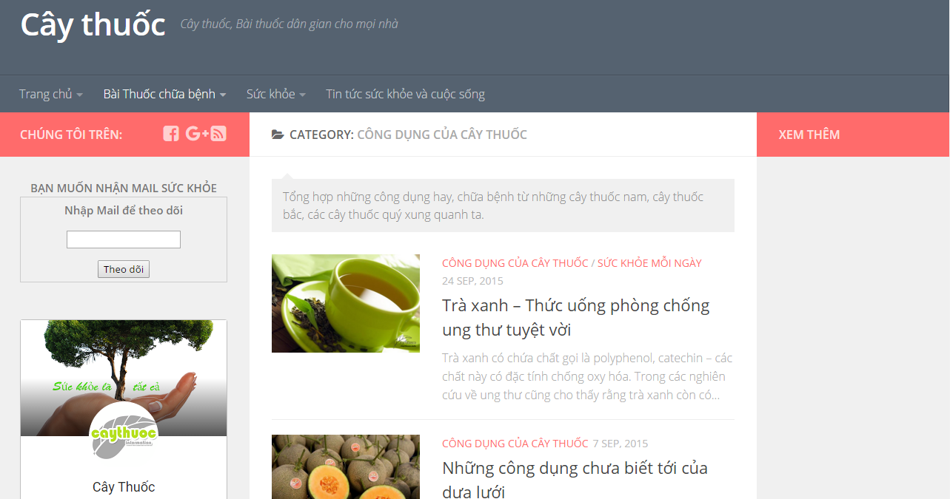

Figure 3‑3: Website Cây thuốc

* **Advantages:**
  + Kind idea for community’s health.
* **Disadvantages:**
  + Name of website and content are not unified.
  + Unfriendly user interface.
  + Organized information is not reasonable.

# PROPOSAL

## The idea

Vietnam Traditional Medicine, also known as eastern medicine, is an original treatment from Vietnam instead of China. Vietnam has the diversity and abundance of medicinal plants and traditional uses of medicinal plants, although the lack of search engines which access to information about medicinal plants.

Along with the strong development of science and technology, our group has an idea and aspiration which about create one system that provides information of medicinal plants in Vietnam, allows searching information on medicinal plants under the utility group.

With each system medicinal plants provides a detail: names of medicinal plants, referral information, descriptions, information on distribution, processing, effects, utility and prescription used medicinal plants.

## Objectives

This project is the Capstone Project in FPT University studying program. It is responsible for all team members, as well as achievements after 4 years study and improve knowledge in FPT University. Therefore, we have to endeavor to complete all requests from teachers, school and group targets set.

During the project, we can learn how to develop a project, how to manage projects, how to communicate better among team members, how to control the time, how to perform effective teamwork, how to apply the knowledge we have learned in efficient way. Moreover, we think that this project is very necessary for us to learn, improve their skills, knowledge. This project will also make our CV look better after graduation FU, this will be a good opportunity for us to demonstrate the capacity for employers.

We also expect the project can be widely used in the education field, health care, such as a document using teaching assistants, illustrated in the courses at the Medicine School, traditional medicine, the project could also assist doctors and nurses in hospitals have used medicinal plants. And more importantly, the project can support ordinary users need to look up information about medicinal plants and useful remedy for their life.

## Brief description about system

Our system will provide information about medicinal plants and traditional remedies with friendly and attractive interface, member can easy to get useful information, they also can share their experiences such as drink ginger tea when headache, … Member can comment and rate with good quality article.

This project uses the familiar technologies: PHP (Laravel Framework), Javascript, bootstrap library, …

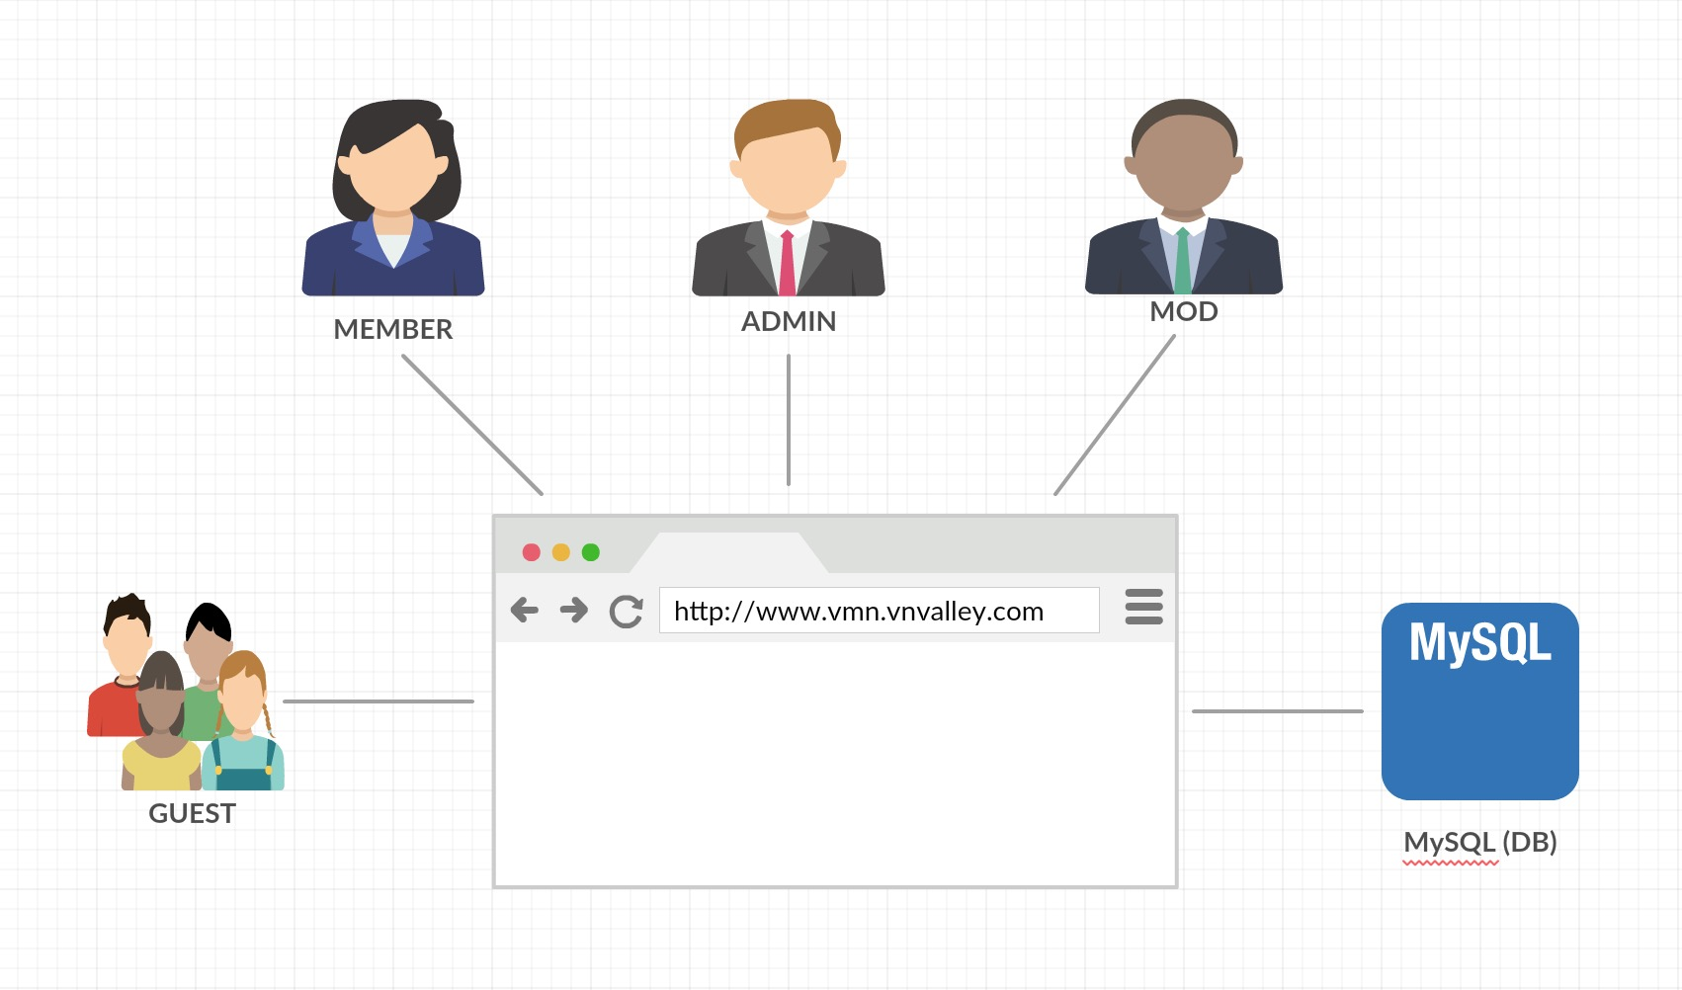

**Figure 1-3:** Brief descriptions diagram of VMN system

## System features

About the features of project, we focus to provide for member main features as searching, create a new article, update their articles, comment/rate articles, etc. Admin can manage members account. Mod can manage members’ articles (approve, review member’s article). Moreover, member and Mod can send message to other.

There are the detailed features of project:

### Member features

* Register: Guest can register an account and login to use features of VMN system.
* Login/Logout/Forgot password: Member can login/logout an account to use or exit system project. If member forgot password, they can reset their password again by email.
* Search:
* Basic Search: Search by name: member can search a medicinal plant at medicinal plant tab, a remedy at remedy tab by name.
* Advance search: Search by utility, allocation place, characteristics… or multiple conditions: member can search by utility, allocation place, characteristics or multiple conditions of medicinal plants or remedies and system will display result as a list which suitable with key words.
* A medicinal plant article:
* Contribution: Member can contribution a new article of medicinal plants with basic info such as: name, utility, allocation place, science name …
* Change content: Member can edit and update their medicinal plant articles but they have to wait of Mod’s approving.
* Comment/Rate: Member can comment/rate a medicinal plant article.
* Report: Member can report a medicinal plant article when it has problem as duplicate, wrong information… to Mod.
* Share/ Like: Member can share a medicinal plant article through facebook.
* A remedy article:
* Contribution: Member can contribution a new article of remedy with basic info such as: title, utility, usage….
* Change content: Member can edit and update their remedy articles but they have to wait of Mod’s approving.
* Comment/Rate: Member can comment/rate an article.
* Report: Member can report a remedy article when it has problem as duplicate, wrong information … to Mod.
* Share/ Like: Member can share a remedy article by facebook.
* Member’s information:
* Change password: Member can change password to keep security.
* Update profile: Member can edit or update their information as name, address, avatar, ...

### Admin features

* Manage member:
* Search user: Admin can search with name of user and system will display simple information about that user (name, email, phone number)
* Inactive/active user: admin can set user’s account to inactive or active.
* Authorization

### Mod features

* Manage Medicinal plant article:
* Search Medicinal plant article:
* Basic search: Mod can search by name of a Medicinal plant article and system will display result as a list which suitable with key words.
* Advance search: Search with utility, allocation place, description… or multiple conditions: Mod can search by utility, allocation place, description… of medicinal plants or remedies and system will display result as a list which suitable with key words.
* Approve new Medicinal plants article: Mod can set status of a Medicinal plant article: pending to approved, pending to suspend, approved to suspend, etc.
* Approve change Medicinal plant article content: Mod has ability to approve Medicinal plant article content’s change of author.
* Add new Medicinal plants article: Mod also can contribute a new medicinal plants as a member.
* Change Medicinal plants article content: Mod can edit and update their Medicinal plants article but he/she does not need to wait for approving.
* Comment/Rate: As a member, Mod also can comment/rate an article.
* Share/ Like an article through facebook.
* Manage Remedy article:
* Search Remedy article:
* Basic search: Mod can search by name of a Remedy article and system will display result as a list which suitable with key words.
* Advance search: Search with utility, description, usage… or multiple conditions: Mod can search by utility, description, usage… of medicinal plants or remedies and system will display result as a list which suitable with key words.
* Approve new Remedy article: Mod can set status of a Remedy article: pending to approved, pending to suspend, approved to suspend, etc.
* Approve change Remedy article content: Mod has ability to approve Remedy article content’s change of author.
* Add new Remedy article: Mod also can create a new remedy as a member.
* Change Remedy article content: Mod can edit and update their Remedy article but he/she does not need to wait for approving.
* Comment/Rate: As a member, Mod also can comment/rate a Remedy article.
* Share/ Like an article through facebook.

# BENEFIT FROM PROJECT

## For our group

After developing and implementing this project, our group will get some benefits:

* Have more experiences of software project management how to manage plan, time, member and risk.
* Have more knowledge and skill about PHP, MySQL, Javascript, Bootstrap library …
* Know how to communicate with team members and how to teamwork more effective.

## For Community

We provide to member information about medicinal plants and traditional remedies. Member can know more the useful information for their health, their life.

Member also can search Herbal medicine store’s information and contact if they need.

# CRITICAL ASSUMPTION AND CONSTRAINTS

* Critical assumption:
  + Training: All developers can train PHP, Bootstrap, GIT in 3 weeks. Before starting this project, just 1 member in our team have knowledge about PHP, Bootstrap and no one have experiences about Laravel framework, but with programming techniques which we studied at FU, we have to try the best to not missing any deadline in project plan.
  + Human resources: Assume that all members in team have a good healthy to do their tasks.
* Constraints:
  + Time and deadline: We must complete task on time. We work on 14 weeks, each member works 5 hours/day and 5 days/week. We do not have more time for us to complete developing and deliver application to supervisor. Besides, we have to submit report documents before deadline to supervisor can review.
  + Quality: The products must be run well when users perform main functions in Google Chrome 40 and Firefox 30 or higher.
  + Process: We have to follow the software processing of FPT Software
  + Human resources: There are 4 members in our team, each member have to study 2 subjects (Japanese and JFE) at school, 2 members have more subject to learn.

# POTENTIAL RISKS

When we are doing capstone project, we can get some risks as describe below:

* Under-estimate scope and time or miss deadline because lack of experience in group working, managing and controlling work.
* Loss data, source code before uploading data to server because of careless.
* Laptop is broken because of careless or accident.
* Human resources: Team member cannot complete their works because of personal reasons: health, family…, key member leave team or un-cooperating on team.
* Change requirements: Requirement changed when some functions cannot be completed or some technologies is not suitable.

# REFERENCES

* **Thuoc nam at URL:**  <https://www.thuocnam.org/>
* **Cay thuoc at URL:** <https://www.caythuoc.info/>
* **Tue Linh at URL:** <https://www.tuelinh.vn/>